MACHINE LEARNING FRAMEWORK FOR SKILL GAP ANALYSIS AND PERSONALIZED LEARNING RECOMMENDATION
A Mini Project Report Submitted in partial fulfillment of the requirements for the award of the degree of
BACHELOR OF TECHNOLOGY
In
DEPARTMENT OF COMPUTER SCIENCE AND ENGINEERING

By
K. Sai Vaishnavi – 2420030660
K. Bhargavi – 2420030661
KL (Deemed to be) University

Under the Esteemed Guidance of
Srilakshmi Potluri


Koneru Lakshmaiah Education Foundation
(Deemed to be University estd. u/s. 3 of the UGC Act, 1956)
Off-Campus: Bachupally-Gandimaisamma Road, Bowrampet, Hyderabad, Telangana - 500 043.
K L (Deemed to be) University

DECLARATION
The mini-project report entitled “Machine Learning Framework for Skill Gap Analysis and Personalized Learning Recommendation” is a record of bona fide work carried out by K. Sai Vaishnavi (2420030660) and K. Bhargavi (2420030661) in partial fulfillment of the requirements for the award of the B.Tech degree at K L (Deemed to be) University. The work presented in this report is original to the best of our knowledge, and all datasets, tools, code, and external sources used have been appropriately acknowledged.

K. Sai Vaishnavi – 2420030660
K. Bhargavi – 2420030661
K L (Deemed to be) University
CERTIFICATE
This is to certify that the mini-project report entitled “Machine Learning Framework for Skill Gap Analysis and Personalized Learning Recommendation” is a bona fide work carried out by K. Sai Vaishnavi (2420030660) and K. Bhargavi (2420030661) in partial fulfillment of the requirements for the award of the Bachelor of Technology degree at K L (Deemed to be) University.

Signature of the Project Supervisor

Signature of the HOD Signature of the External Examiner
ACKNOWLEDGEMENT
The success of this project would not have been possible without the timely help and guidance rendered by many people. We wish to express our sincere thanks to all those who have assisted us in one way or the other in the completion of our project.
Our greatest appreciation goes to our project guide, whose tremendous support, encouragement and guidance cannot be expressed in words.
We express our gratitude to the Head of the Department, for providing us with adequate facilities, ways and means by which we were able to complete this project-based lab.
We thank all the teaching and non-teaching staff members who have assisted us directly or indirectly in the successful completion of this project. Finally, we sincerely thank our parents, friends and classmates for their kind help and cooperation during our work.

K. Sai Vaishnavi – 2420030660
K. Bhargavi – 2420030661
TABLE OF CONTENTS
S.No. | Contents | Page no.
1. | Abstract | 6
2. | Introduction | 7
3. | Literature Survey | 9
4. | Problem Statement and Objectives | 12
5. | Hardware and Software Requirements | 13
6. | Implementation | 14
7. | Results and Discussion | 17
8. | Conclusion and Future Scope | 22
9. | References | 23

1. ABSTRACT
Students and job seekers find it hard to identify the gap between their current skills and the competencies demanded by a target job role. This project presents a machine-learning framework that analyses a user’s skill profile, identifies the missing skills for a selected role, and recommends a ranked set of courses to close them. The pipeline cleans and normalises job-description text, represents it with TF-IDF features, classifies postings into 8 job roles using four classifiers (Naive Bayes, Logistic Regression, Linear SVM, Random Forest), derives role skill profiles from training postings only, extracts skills from free-text student profiles using a lexicon combined with character n-gram similarity, and retrieves courses by TF-IDF cosine similarity. Because the O*NET and Kaggle datasets could not be downloaded in the development environment, all experiments were run on a documented, synthetic demonstration dataset of 1200 job descriptions, 200 student profiles and 171 courses. On the held-out test set (240 postings), Linear SVM gave the best cross-validated macro F1 and reached 99.6% accuracy and 0.996 macro F1. Skill-gap identification reached F1 of 0.994 with fuzzy matching versus 0.950 with exact matching, and course retrieval reached Hit@1 of 88.3%. As the data are synthetic, these figures show that the pipeline works end to end, not real-world performance. The framework can support career counselling and self-directed learning once it is re-evaluated on real data.

Team Members and Responsibilities:
- K. Sai Vaishnavi, 2420030660 (Team Lead) – problem formulation, dataset preparation, NLP preprocessing and skill extraction.
- K. Bhargavi, 2420030661 – feature engineering, model training and evaluation, recommendation module and report writing.
Dataset/source and project repository:
Planned real sources: O*NET Skills Database (https://www.onetcenter.org/database.html), Kaggle job-skills datasets (https://www.kaggle.com/), Coursera/Udemy course datasets and a custom student skills dataset collected through Google Forms. Demonstration data used in this report: generated by the project script (jobs_demo.csv, courses_demo.csv).

2. INTRODUCTION

2.1 Application Area
Technology evolves faster than most curricula. New tools, frameworks and job titles appear every year, and employers describe the skills they need in long, unstructured job descriptions. A student who wants to become a data scientist, a DevOps engineer or an Android developer must work out which skills the role needs, which of them she already has, and what to learn next. Doing this by hand means reading many postings, comparing them with a resume and searching through thousands of online courses. It is slow, subjective and hard to repeat.
Text analytics addresses this problem. Job descriptions, resumes and course catalogues are all unstructured text, and machine-learning methods can find patterns in them at a scale no person can read. This project applies text classification, skill extraction and similarity-based retrieval to the domain of career readiness and personalised learning.

2.2 Why Manual Analysis Does Not Scale
- Volume: a single role can have thousands of postings, each phrasing the same skill differently (for example “ML”, “machine learning”, “sklearn”).
- Inconsistency: keyword searches miss synonyms, abbreviations and spelling variations.
- Personalisation: every learner has a different starting point, so one generic course list is not enough.
- Maintenance: skill requirements change, so a hand-made mapping becomes outdated quickly.

2.3 Target Users and Intended Use
The framework is intended for students, job seekers and working professionals, and can also support college placement cells and training departments. A user chooses a target job role and supplies a short skill profile or resume text. The system returns the missing skills, a readiness score, and an ordered list of recommended learning resources.

2.4 Input and Output
Input: (a) job-description text used to learn role skill profiles and to train the role classifier; (b) free-text student skill profile and the chosen target role; (c) a catalogue of course titles and descriptions. Output: (a) predicted job role for a job description; (b) the set of skills extracted from the student profile; (c) the list of missing skills with importance weights; (d) a ranked learning path of courses.

2.5 Proposed Pipeline
The pipeline has seven stages: data collection, cleaning and preprocessing, feature representation (TF-IDF), model training, skill extraction and gap identification, recommendation and ranking, and evaluation. A simple dashboard (Streamlit) is proposed as an optional interface; in this report the workflow is run from a notebook/script.

2.6 Organisation of the Report
Chapter 3 surveys related work. Chapter 4 states the problem and objectives. Chapter 5 lists hardware and software requirements. Chapter 6 describes the implementation. Chapter 7 presents results and discussion. Chapter 8 concludes the work and outlines future scope, and Chapter 9 lists the references.

3. LITERATURE SURVEY
This chapter reviews nine works that underpin the text-representation, classification, skill-extraction and recommendation stages of the project. Each summary states the problem, data, method, main finding and limitation. Citation numbers refer to Chapter 9.
1. Term-weighting approaches in automatic text retrieval [2]
Salton and Buckley studied how words in documents and queries should be weighted for retrieval. They compared many term-frequency, collection-frequency and length-normalisation schemes on standard retrieval collections. Combining term frequency with inverse document frequency gave consistently strong results and became the standard TF-IDF representation. Limitation: the representation ignores word order and treats synonyms as unrelated terms.
2. Text categorization with Support Vector Machines [3]
Joachims examined why SVMs suit text classification, where feature spaces are very high-dimensional and sparse. He evaluated them on the Reuters and Ohsumed collections against Naive Bayes, Rocchio, decision-tree and k-NN baselines. SVMs performed best without heavy feature selection. Limitation: the work used bag-of-words features and offers no semantic understanding of terms.
3. Random Forests [4]
Breiman introduced Random Forests, ensembles of decision trees grown on bootstrap samples with random feature selection at each split. The paper shows that generalisation error converges as trees are added and relates accuracy to the strength and correlation of the trees. Forests were competitive with boosting on many benchmark datasets. Limitation: the model is harder to interpret than a single tree and can be less effective than linear models on very sparse text.
4. XGBoost: A scalable tree boosting system [5]
Chen and Guestrin presented XGBoost, a gradient-boosted tree system with sparsity-aware split finding, regularised objectives and cache-efficient computation. It achieved state-of-the-art results on many large tabular and structured-data benchmarks. It is the boosting option named in our proposed approach. Limitation: it needs careful hyper-parameter tuning and gives little advantage over linear models on plain TF-IDF text features.
5. BERT: Pre-training of deep bidirectional transformers [6]
Devlin et al. pre-trained a bidirectional transformer on large unlabelled corpora and fine-tuned it on downstream tasks. BERT improved results on eleven language-understanding benchmarks. Contextual embeddings handle polysemy and synonyms far better than TF-IDF. Limitation: fine-tuning needs substantial compute and labelled data, and the raw model is not designed to produce sentence vectors for fast similarity search.
6. Sentence-BERT: Sentence embeddings using Siamese BERT networks [1]
Reimers and Gurevych modified BERT with siamese and triplet networks so that sentences are mapped to fixed-size vectors comparable by cosine similarity. On semantic-similarity benchmarks it matched or beat earlier sentence-embedding methods, and it cut the time to find the most similar pair among 10,000 sentences from hours to seconds. This is the basis of the semantic skill matching proposed in the project abstract. Limitation: general-purpose models are not trained on skill vocabulary and may need domain adaptation.
7. SkillSpan: Hard and soft skill extraction from English job postings [7]
Zhang et al. released an annotated dataset of job-posting sentences with skill and knowledge spans from several sources and evaluated BERT-style span-extraction models, including a model further pre-trained on job postings. Domain-adapted models outperformed general ones. Limitation: the task extracts spans but does not map them to a skill taxonomy or to learning resources, and the data are in English only.
8. O*NET Resource Center [8]
O*NET is the U.S. Department of Labor’s occupational database and describes occupations by the skills, knowledge, abilities and tasks they require. It gives a curated, regularly updated skill taxonomy that can serve as a reference for role profiles. Limitation: it is a U.S.-centric taxonomy, updates lag behind fast-moving technology skills, and it holds no learning resources.
9. Scikit-learn: Machine learning in Python [9]
Pedregosa et al. describe the scikit-learn library, which offers a consistent API for preprocessing, feature extraction, classical classifiers, cross-validation and metrics. Pipelines allow vectorisers to be fitted on training folds only, which prevents leakage. This project uses it for all models and evaluation. Limitation: deep, contextual models are outside its scope.

3.1 Comparison and Research Gap
Approach | Strength | Limitation for this task
TF-IDF + linear models [2][3] | Fast, accurate on sparse text, interpretable | No semantics; synonyms treated as different
Tree ensembles [4][5] | Non-linear, robust | Heavier, little gain on sparse text
Transformers / SBERT [1][6] | Contextual and semantic similarity | Compute cost; not skill-specific
Skill extraction [7] | Domain-adapted span extraction | No gap analysis or recommendations
O*NET taxonomy [8] | Curated role-skill reference | No learner-specific analysis or courses

The surveyed work covers representation, classification and skill extraction separately. Few studies join the full chain – skill extraction from a learner’s profile, comparison with a data-driven role profile, and course recommendation in an importance-ranked order. This mini-project builds that complete chain with lightweight, reproducible methods (TF-IDF, character n-gram matching, cosine similarity) and keeps a path open to sentence embeddings.

4. PROBLEM STATEMENT AND OBJECTIVES

Problem Statement
To build a text-analytics and machine-learning framework that extracts skills from a learner’s profile, compares them with the skills required for a chosen job role, and outputs the missing skills together with a ranked list of courses to close the gap.

Problem Description
Learners cannot easily tell which skills a job role requires or how far they are from it. Manual reading of job postings and course catalogues is slow, subjective and does not account for differences in wording or in each learner’s starting point. Keyword search alone misses abbreviations and spelling variants. The framework serves students, job seekers and professionals, and automates gap detection and course selection.

Objectives
- Obtain and inspect a labelled text dataset of job descriptions; document its source, size, fields and class distribution.
- Clean and preprocess the text using appropriate NLP steps.
- Convert text to numerical features using TF-IDF.
- Train and compare four machine-learning models (Naive Bayes, Logistic Regression, Linear SVM, Random Forest) for job-role classification.
- Evaluate with accuracy, precision, recall, F1-score and a confusion matrix; evaluate skill-gap identification and course retrieval with precision, recall, F1 and Hit@k.
- Interpret errors and discuss bias, limitations, privacy and improvements.
- Demonstrate the full workflow (skill extraction, gap identification, recommendation) on a worked example.

5. HARDWARE AND SOFTWARE REQUIREMENTS

Hardware Requirements
- Computer/laptop with a modern multi-core CPU; 8 GB RAM or more recommended.
- Internet access for downloading datasets and packages. A GPU is optional and is needed only if transformer embeddings are added.
- Sufficient disk space for dataset files, notebooks, saved models and result figures.

Software Requirements
Component | Details
Language / environment | Python 3.12 with Jupyter Notebook or Google Colab
Data handling | pandas 3.0, NumPy 2.4
Machine learning | scikit-learn 1.8 (TfidfVectorizer, MultinomialNB, LogisticRegression, LinearSVC, RandomForestClassifier, Pipeline, StratifiedKFold)
Visualisation | Matplotlib 3.10
Dataset formats | CSV (job descriptions, courses); source and licence to be documented per dataset (O*NET: CC BY 4.0 – verify on the O*NET site; Kaggle: per-dataset licence)
Optional | Streamlit/Flask for a demo interface; Git for version control; sentence-transformers for embeddings (future work)

6. IMPLEMENTATION

6.1 Data and Task
The project has three linked tasks: (1) classify a job description into one of eight roles; (2) extract skills from a student profile and identify the gap against the role profile; (3) recommend courses for each missing skill.
Note on data. The real datasets listed in the proposal (O*NET, Kaggle job-skills, Coursera/Udemy, custom student survey) could not be downloaded in the environment where this prototype was built. To test the pipeline end to end, the script pipeline.py generates a documented synthetic dataset with a fixed random seed (42). All results in Chapter 7 are therefore measured on synthetic data and must not be read as real-world performance. Replacing the CSV files with the real datasets and re-running the same code is the intended next step.
Table 6.1: Demonstration dataset summary
Item | Description
Job descriptions | 1200 (150 per role × 8 roles), fields: text, role
Roles | Data Scientist, ML Engineer, Web Developer, Data Analyst, DevOps Engineer, Cybersecurity Analyst, Android Developer, Cloud Engineer
Skill vocabulary | 57 canonical skills with synonyms and abbreviations (e.g., ML, sklearn, K8s, JS)
Generation | Each posting has 5–8 core skills of its role, 1–3 skills from other roles (noise) and 3 filler sentences
Train / test split | 960 training / 240 test postings, stratified, seed 42
Student profiles | 200 profiles; each knows about 45% of its role’s required skills; 30% of mentions contain spelling/spacing noise
Course catalogue | 171 courses (3 levels per skill: Beginner, Intermediate, Advanced)

6.2 NLP Preprocessing and Features
- Cleaning: text is lower-cased; punctuation is handled by the tokenizer; no missing values or duplicates exist in the generated data, but the loader checks for both.
- Tokenisation and stop words: scikit-learn’s tokenizer with English stop-word removal. Stemming and lemmatisation were not applied, since skill names such as “pandas” or “kubernetes” should stay intact.
- Representation: TF-IDF with unigrams and bigrams (so “machine learning” is a feature), sublinear term frequency and min_df = 2. The vectoriser is part of a scikit-learn Pipeline, so it is fitted on training folds only, which avoids data leakage.
- Skill normalisation: a lexicon maps every variant to one canonical skill (“sklearn” → scikit-learn). Matching uses word boundaries so “java” does not match “javascript” and “sql” does not match “sqlite”.
- Fuzzy matching: each comma/period-separated phrase of a profile is compared with all lexicon entries by cosine similarity of character 2–4-gram TF-IDF vectors; a phrase is accepted when similarity ≥ 0.62. This recovers variants such as “scikitlearn” or “tensorflo”.

6.3 Model Training and Evaluation
Aspect | Setting
Classifiers and hyperparameters | Multinomial NB (alpha = 0.5); Logistic Regression (C = 10, max_iter = 1000); Linear SVM (C = 1.0); Random Forest (200 trees)
Random seed | 42 for data generation, splitting, cross-validation and models
Validation | 5-fold stratified cross-validation on the training set; macro F1 used for selection
Model selection | Highest mean cross-validated macro F1; test set used once for final reporting
Metrics | Accuracy, macro precision/recall/F1, per-class report, confusion matrix
Role skill profile | Skills present in at least 40% of the role’s training postings (computed on the training split only)
Gap definition | required skills of the role minus skills extracted from the student profile
Recommendation | TF-IDF (char 2–4-gram) cosine similarity between a query “learn <skill>” and course title + description; top-k retrieved; gaps ordered by skill importance (share of postings)

A. Project Workflow and Modules
- Data generation, loading and exploratory analysis: pipeline.py (section 1).
- Text cleaning and preprocessing: pipeline.py (TfidfVectorizer inside Pipeline; skill lexicon).
- Feature extraction and model training: pipeline.py (sections 2 and 3).
- Evaluation, plots and error analysis: pipeline.py (sections 3, 4 and figures).

B. Machine-Learning Implementation
Naive Bayes is the baseline because it is fast and strong on sparse counts. Logistic Regression and Linear SVM are linear models that work well in high-dimensional TF-IDF space. Random Forest provides a non-linear, ensemble comparison. Key excerpts follow.
vec = lambda: TfidfVectorizer(lowercase=True, ngram_range=(1, 2),
sublinear_tf=True, stop_words='english', min_df=2)
for name, m in models.items():
pipe = Pipeline([('tfidf', vec()), ('clf', m)]) # TF-IDF fitted on train folds only
cvs = cross_val_score(pipe, Xtr, ytr, cv=cv, scoring='f1_macro')
pipe.fit(Xtr, ytr); pred = pipe.predict(Xte)

def fuzzy_extract(text, thr=0.62):
found = exact_extract(text) # lexicon with word boundaries
for ph in re.split(r'[,.;:]', text):
sims = cosine_similarity(cv_char.transform([ph.strip().lower()]), KM)[0]
if sims.max() >= thr: found.add(canon[keys[sims.argmax()]])
return found

gap = set(required_skills[role]) - fuzzy_extract(profile_text)
path = sorted(gap, key=lambda s: -role_profile[s]) # most important skills first
for s in path: course = courses[recommend('learn ' + s, k=1)[0]]

C. Demonstration
No web interface was built in this phase. The workflow is demonstrated through the script/notebook; Section 7.5 shows a worked example. A Streamlit page with a role drop-down, a text box for the profile and a results table would reuse the same functions (fuzzy_extract, role_profile, recommend) without change.

7. RESULTS AND DISCUSSION
Reminder: all numbers below come from running pipeline.py on the synthetic demonstration dataset (seed 42). They demonstrate that the pipeline works; they are not evidence of real-world accuracy.

7.1 Dataset Summary and Preprocessing
The dataset has 1200 job descriptions evenly distributed over eight roles (150 each), so class imbalance is not a factor in this experiment (Figure 7.1). A preprocessing example: the raw text “Requirements include ML, sklearn, K8s. We are looking for a motivated candidate…” becomes lower-cased tokens and bigrams with stop words removed, then a sparse TF-IDF vector.
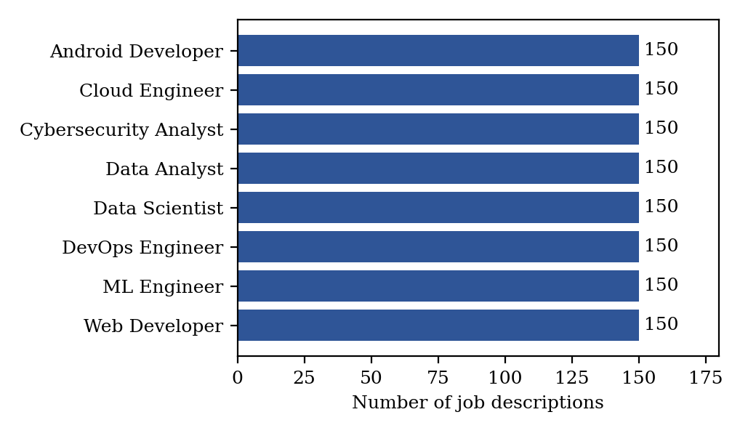
Figure 7.1: Class distribution of the demonstration job-description dataset
Figure 7.1 confirms that the classes are balanced, so accuracy and macro F1 are directly comparable and no re-sampling was needed.

7.2 Model Comparison for Role Classification
Table 7.1: Model comparison (5-fold CV on training set; metrics on test set)
Model | CV macro F1 | Accuracy | Macro precision | Macro recall | Macro F1 | CV std
Multinomial Naive Bayes | 0.984 | 0.992 | 0.992 | 0.992 | 0.992 | 0.003
Logistic Regression | 0.994 | 0.996 | 0.996 | 0.996 | 0.996 | 0.004
Linear SVM * | 0.995 | 0.996 | 0.996 | 0.996 | 0.996 | 0.003
Random Forest | 0.973 | 0.983 | 0.984 | 0.983 | 0.983 | 0.014
* selected model (highest CV macro F1).
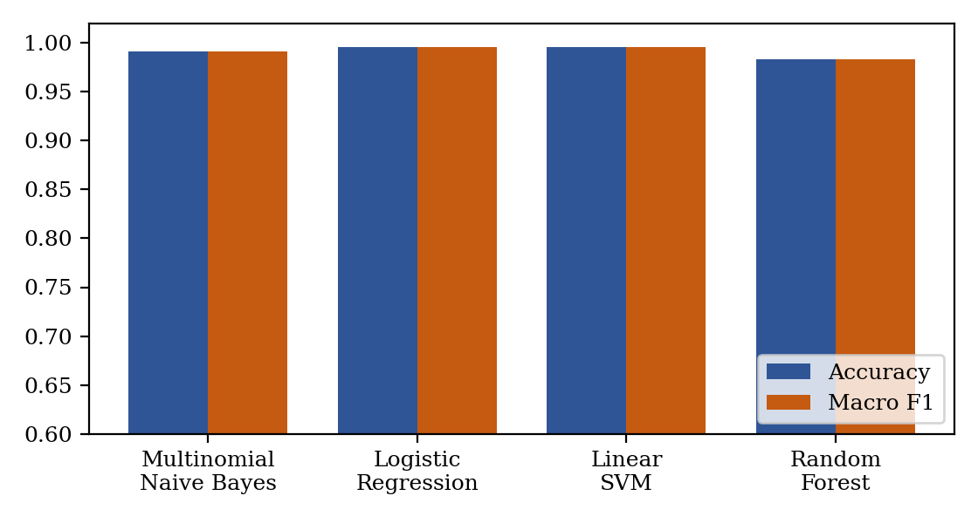
Figure 7.2: Test accuracy and macro F1 of the four classifiers
Linear SVM was selected with CV macro F1 of 0.995. Logistic Regression and Linear SVM were practically tied on the test set (99.58% and 99.58% accuracy), Naive Bayes reached 99.17%, and Random Forest was lowest at 98.33% with the highest fold-to-fold variation (std 0.014). Linear models suit sparse TF-IDF features, which agrees with the literature. Differences of one or two test postings (each posting is about 0.42%) are too small to rank the top models with confidence.

7.3 Class-wise Performance and Error Analysis
Table 7.2: Per-class results of Linear SVM on the test set
Role | Precision | Recall | F1
Android Developer | 1.000 | 1.000 | 1.000
Cloud Engineer | 1.000 | 0.967 | 0.983
Cybersecurity Analyst | 0.968 | 1.000 | 0.984
Data Analyst | 1.000 | 1.000 | 1.000
Data Scientist | 1.000 | 1.000 | 1.000
DevOps Engineer | 1.000 | 1.000 | 1.000
ML Engineer | 1.000 | 1.000 | 1.000
Web Developer | 1.000 | 1.000 | 1.000
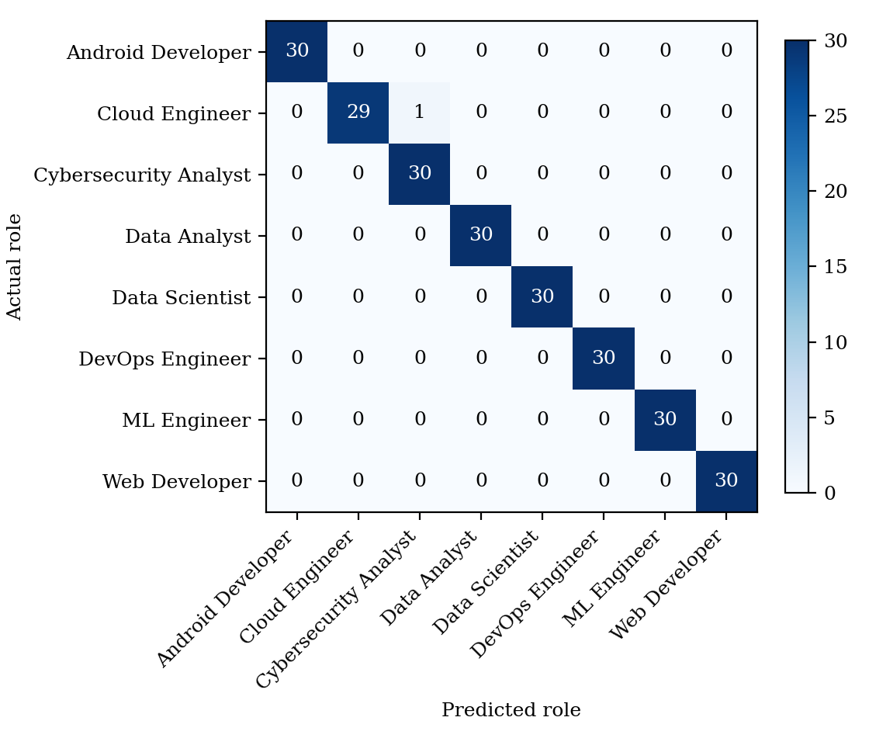
Figure 7.3: Confusion matrix of Linear SVM on the 240-posting test set
The classifier made a single error among 240 test postings: Cloud Engineer recall and Cybersecurity Analyst precision are the only values below 1.0, so one Cloud Engineer posting was predicted as Cybersecurity Analyst. Both roles share skills such as Linux and Python, which explains the confusion. Perfect scores for the other roles arise because the synthetic postings come from a fixed vocabulary, which is much easier than real postings; on real data we expect more overlap (for example Data Scientist versus ML Engineer) and lower scores.

7.4 Skill Extraction, Gap Identification and Recommendation
Table 7.3: Role skill profiles learned from training postings (skills in ≥ 40% of postings, ordered by frequency)
Role | Required skills
Android Developer | git, firebase, ui design, kotlin, sqlite, rest api, android sdk, jetpack compose, java
Cloud Engineer | python, terraform, docker, iam, kubernetes, serverless, aws, linux, networking, azure
Cybersecurity Analyst | incident response, firewalls, cryptography, network security, python, penetration testing, vulnerability assessment, linux, siem
Data Analyst | excel, reporting, sql, power bi, statistics, data cleaning, python, tableau, data visualization
Data Scientist | hypothesis testing, statistics, data visualization, pandas, sql, scikit-learn, deep learning, feature engineering, numpy, machine learning, python
DevOps Engineer | aws, bash, git, ci/cd, ansible, kubernetes, linux, monitoring, terraform, docker, jenkins
ML Engineer | machine learning, sql, pytorch, kubernetes, docker, mlops, git, model deployment, deep learning, python, tensorflow
Web Developer | javascript, css, html, typescript, rest api, git, mongodb, sql, react, node.js

Table 7.4: Skill extraction and gap identification on 200 synthetic student profiles
Method | Skill recall | Gap precision | Gap recall | Gap F1
Exact lexicon matching | 0.876 | 0.908 | 0.996 | 0.950
Lexicon + character n-gram matching | 0.989 | 0.991 | 0.996 | 0.994
Skill recall is the share of a student’s true known skills that were found. Gap precision and recall compare predicted missing skills with the true missing skills.
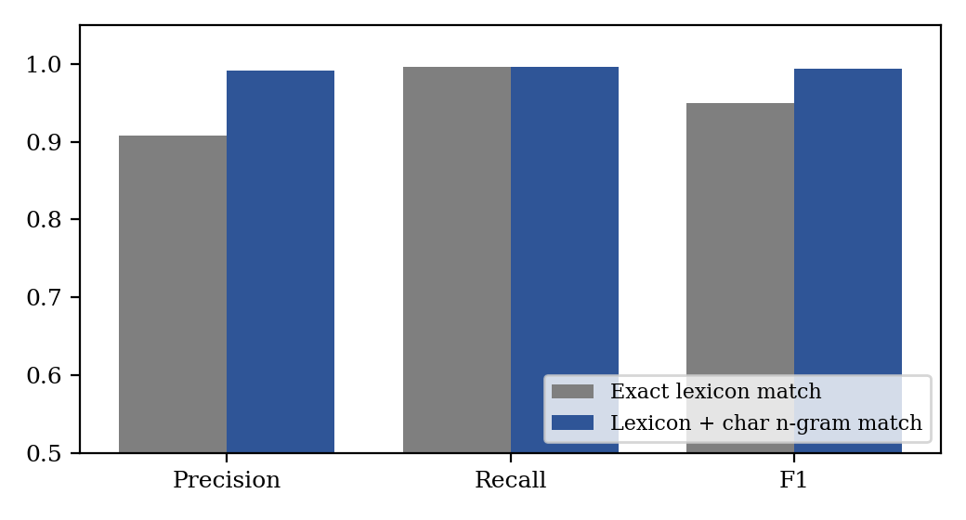
Figure 7.4: Skill-gap identification with exact versus fuzzy skill matching
Exact matching misses misspelled or re-spaced skills, so it wrongly reports them as gaps: skill recall is 87.6% and gap precision 0.908. Adding character n-gram similarity raises skill recall to 98.9% and gap F1 from 0.950 to 0.994 with no loss in gap recall. The noise types in the generated profiles (dropped letters, removed spaces, extra words) are simple, so real resumes will be harder, and semantic synonyms with no character overlap would still be missed. This is where sentence embeddings would add value.
Across the 200 profiles, the mean readiness score (share of required skills already held) was 44.9% and the mean gap was 5.53 skills per student. For recommendation, 1105 missing-skill queries were run (30% with noisy spelling); the correct skill’s course was ranked first in 88.3% of cases (Hit@1) and within the top three in 89.3% (Hit@3). Failures come mainly from misspelled queries that resemble another skill’s name.
Table 7.5: Recommendation retrieval results
Metric | Value | Queries
Hit@1 | 88.3% | 1105
Hit@3 | 89.3% | 1105

7.5 Worked Example
A student targeting Data Scientist wrote: “Skills and tools: pytorch, AWS, sql, statistics, html, python, pandas, scikit-learn, ML. Interests: open source.”. The system found these role-relevant skills: machine learning, pandas, python, scikit-learn, sql, statistics. The missing skills and the learning path, in order of importance, are:
Table 7.6: Personalised learning path for the example student
Order | Missing skill | Importance | Recommended course | Level
1 | hypothesis testing | 0.67 | Hypothesis Testing for Practitioners | Intermediate
2 | data visualization | 0.62 | Data Visualization for Practitioners | Intermediate
3 | deep learning | 0.60 | Deep Learning for Practitioners | Intermediate
4 | feature engineering | 0.57 | Feature Engineering for Practitioners | Intermediate
5 | numpy | 0.57 | Numpy for Practitioners | Intermediate

Importance is the share of training postings of the role that mention the skill. The top retrieved course for each skill was an Intermediate-level course because the retriever ranks by topical similarity only; level-aware sequencing (Beginner before Advanced) is listed as future work.

7.6 Limitations
- Synthetic data: the vocabulary is controlled, so scores are near ceiling and do not predict real-world performance.
- Ground truth: gaps and role profiles are defined from the same lexicon, so the evaluation is partly circular; real validation needs human-labelled resumes.
- Bias and fairness: real postings may encode regional or gender-coded wording; role profiles learned from them can inherit such bias.
- Privacy: resumes contain personal data; real deployment needs consent, minimal storage and anonymisation.
- Recommendation quality: retrieval accuracy was measured against skill labels, not against learner outcomes or course quality.

8. CONCLUSION AND FUTURE SCOPE
This project built a pipeline for skill-gap analysis and personalised learning recommendation. Job descriptions were represented with TF-IDF and classified into eight roles by four models; Linear SVM was selected by cross-validation and reached 99.58% test accuracy and 0.996 macro F1. Role skill profiles learned from training postings were used to identify gaps in student profiles, where fuzzy skill matching improved gap F1 from 0.950 to 0.994 over exact matching. TF-IDF retrieval ranked the right course first in 88.3% of queries.
All objectives were achieved on the demonstration data: the dataset was documented, text was preprocessed, TF-IDF features were built, four models were trained and compared, the required metrics and a confusion matrix were reported, errors and limitations were discussed, and the full workflow was demonstrated through a worked example. The objective of using real, labelled datasets was not met in this phase, which is the most important limitation: the scores come from synthetic data and need to be re-measured on O*NET/Kaggle and survey data.

Future Scope
- Re-run all experiments on real job-description, course and student-survey datasets, and report the new results.
- Replace or complement character n-gram matching with sentence embeddings (Sentence-BERT) for true semantic skill matching.
- Fine-tune a transformer such as BERT for skill extraction and compare it with the TF-IDF baseline.
- Add level-aware and prerequisite-aware ordering of courses, and consider course ratings, duration and cost.
- Build a Streamlit dashboard with progress tracking and career-readiness analytics, and measure response latency.
- Add explainability (why a skill is flagged) and privacy-aware handling of resumes.

9. REFERENCES
- N. Reimers and I. Gurevych, “Sentence-BERT: Sentence Embeddings using Siamese BERT-Networks,” in Proc. EMNLP-IJCNLP, 2019, pp. 3982–3992. https://arxiv.org/abs/1908.10084
- G. Salton and C. Buckley, “Term-weighting approaches in automatic text retrieval,” Information Processing & Management, vol. 24, no. 5, pp. 513–523, 1988. https://doi.org/10.1016/0306-4573(88)90021-0
- T. Joachims, “Text categorization with Support Vector Machines: Learning with many relevant features,” in Proc. ECML, 1998, pp. 137–142. https://doi.org/10.1007/BFb0026683
- L. Breiman, “Random Forests,” Machine Learning, vol. 45, no. 1, pp. 5–32, 2001. https://doi.org/10.1023/A:1010933404324
- T. Chen and C. Guestrin, “XGBoost: A Scalable Tree Boosting System,” in Proc. ACM SIGKDD, 2016, pp. 785–794. https://doi.org/10.1145/2939672.2939785
- J. Devlin, M.-W. Chang, K. Lee and K. Toutanova, “BERT: Pre-training of Deep Bidirectional Transformers for Language Understanding,” in Proc. NAACL-HLT, 2019. https://arxiv.org/abs/1810.04805
- M. Zhang, K. N. Jensen, S. D. Sonniks and B. Plank, “SkillSpan: Hard and Soft Skill Extraction from English Job Postings,” in Proc. NAACL, 2022. https://aclanthology.org/2022.naacl-main.366
- National Center for O*NET Development, “O*NET Resource Center – Database,” U.S. Department of Labor. https://www.onetcenter.org/database.html
- F. Pedregosa et al., “Scikit-learn: Machine Learning in Python,” Journal of Machine Learning Research, vol. 12, pp. 2825–2830, 2011. https://scikit-learn.org/stable/
- Kaggle datasets for job descriptions/skills and online-course catalogues. https://www.kaggle.com/

